APPENDIX-1
(A typical Specimen of Cover Page & Title Page)

AUTOMATIC ROOM TEMPERATURE CONTROLLER

A PROJECT REPORT

Submitted by

SAHIL KAUNDAL
ROHIT KUMAR GOSWAMI
FEROJ KHAN
PRATIK KUMAR DEY

In partial fulfilment for the award of the degree of

BACHELOR IN ENGINEERING

IN

COMPUTER SCIENCE AND ENGINEERING



Chandigarh University

MAY 2022
APPENDIX-2
(A typical Specimen of Bonafide Certificate)

BONAFIDE CERTIFICATE

Certified that this project report “AUTOMATIC ROOM TEMPERATURE CONTROLLER “is the bonafide work of “SAHIL KAUNDAL, ROHIT KUMAR GOSWAMI, FEROJ KHAN, PRATIK KUMAR DEY “who carried out the project work under our supervision.

SIGNATURE SIGNATURE
(Head of the Dept.) (Supervisor)

SHUVENDU DAS (12496) DR. PUNIT KUMAR
SUPERVISOR HEAD OF THE DEPARTMENT

Submitted for the project viva-voce examination held on __________________

INTERNAL EXAMINER EXTERNAL EXAMINER

ACKNOWLEDGEMENT

We taken effort in this project. However, it would not have been possible without the kind support and help of many individuals and organization. We would like to extend our sincere thanks to all of them.

We are very grateful to Mr. Shuvendu Das and Mrs. Bhanu Thakur for their
guidance and constant supervision as well as for providing necessary information
regarding the project and also for their support in completing the project.

Thank You.

TABLE OF CONTENTS

TITLE PAGE i

BONAFIDE CERTIFICATE ii

ACKNOWLEDGEMENT iii

TABLE OF CONTENTS iv

LIST OF FIGURES v

LIST OF TABLES vi

ABSTRACT vii

GRAPHICAL ABSTRACT viii

ABBREVIATIONS ix

SYMBOLS x

CHAPTER 1 INTRODUCTION 14 - 16
 |  | 1.1 | Project Background |  |  |  |  | 14
 |  | 1.2 | Problem Statement |  |  |  |  | 15
 |  | 1.3 | Objectives |  |  |  |  | 15
 |  | 1.4 | Scope of The Project |  |  |  |  | 16

CHAPTER 2 LITERATURE SURVEY 17 -26
 |  | 2.1 | Related Work |  | 17
 |  | 2.2 | Sensors |  | 20
 |  | 2.3 | TMP36 Sensor |  | 20
 |  | 2.4 | Microcontroller  2.4.1 Alf and Vegard’s RISC processor (AVR)  2.4.2 8051 Microcontroller  2.4.3 Programmable Interface Controller (PIC) |  | 21
 |  | 2.5 | Arduino  2.5.1 Arduino UNO Rev 3 |  | 23
 |  | 2.6 | LCD (Liquid Crystal Display) |  | 26

CHAPTER 3 DESIGN FLOW/PROCESS 27 - 30
 |  | 3.1 | Introduction |  |  | 27

CHAPTER 4 RESULTS ANALYSIS AND VALIDATION 31 - 42
4.1 Report preparation 31
4.2 Arduino 31
4.2.1 Programming of Arduino
4.3 Breadboard Supply 34
4.4 LCD Display 34 4.5 Temperature Sensor 35 4.6 Heater (LED) 36 4.7 Cooling (DC Motor) 37 4.8 8051 Microcontroller 37 4.9 Diode 37 4.10 Transistor 38
4.11 Communication and Validation (Cost, Scope, Quality, Benefits) 38

CHAPTER 5 CONCLUSION AND FUTURE WORK 43 - 46
5.1 Conclusion 43
5.2 User Manual 43
5.3 References 45

LIST OF FIGURES

3.1 Flowchart for Automatic Room Temperature Controller 28
3.2 Data Flow Diagram 29
3.3 Block Diagram 29
3.4 Project Channel for Automatic Room Temperature controller 30
3.5 Circuit Diagram for Automatic Room Temperature controller 30
4.1 Arduino UNO Diagram 32
4.2 Arduino UNO Pins Diagram 33
4.3 A Sketch of Arduino IDE Window 33
4.4 Breadboard Power Supply 34
4.5 Output of the Sketch on a 16x2 LCD 35
4.6 TMP36 Temperature Sensor 36
4.7 Diode 1N4007 37
4.8 Transistor 38

LIST OF TABLES

2.1 Electrical characteristics of TMP36 sensor 21
4.1 LCD pins and their connections 35

ABSTRACT

Temperature control refers to the processes that are aimed at maintaining the
temperature in a given area at certain maximum/minimum level or within a certain range.
Many Homes and Industries among other areas maintain certain sections of operation that must be maintained within a certain temperature for process to work successfully. In areas that have electronic activities or machinery functioning constantly, such as in server rooms and production plants. These are places where heavy machinery and computers work continuously 24 hours every day. During these processes, the temperature needs to be monitored frequently in order to ensure that it doesn’t rise or fall below a value that would accelerate wearing out of the systems.

Automatic room temperature controller is certified as the best method in any application because the temperature is usually controlled automatically throughout the process. The results obtained from various applications of the process across different regions and timelines shows the temperature is controlled effectively and more accurately. In addition, this finding also makes human work easier as an automatically controlled system worries about other contingent weather issues for you. The major objective of this project would be to create an Automatic Room Temperature Controller System that would be able to automatically control the temperature of the room it is placed in by the timely activation of the effector devices to influence the temperature in relation to the set-point.

Keywords: Room Temperature, Heater, Cooling, Homes and Industries.
GRAPHICAL ABSTRACT

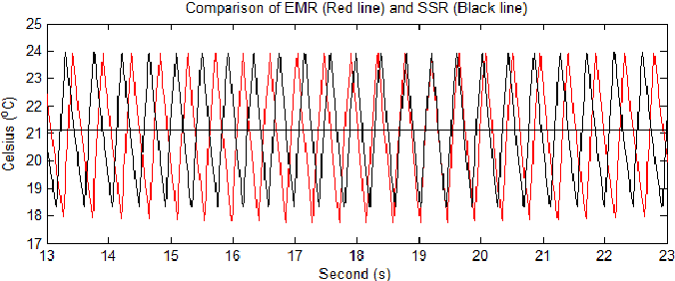

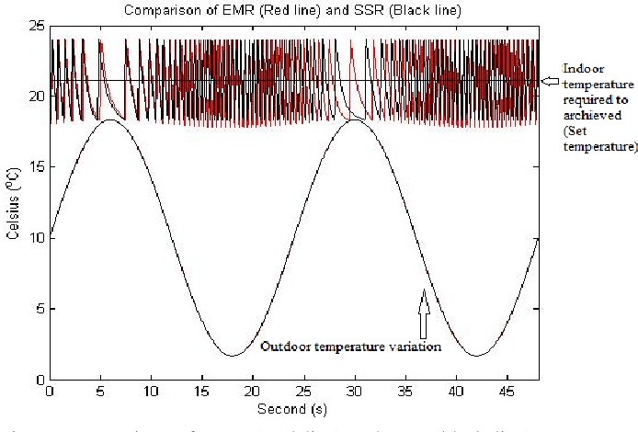

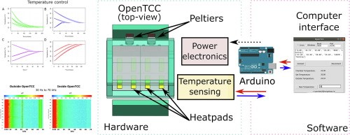

LISTS OF SYMBOLS AND ABBREVIATIONS

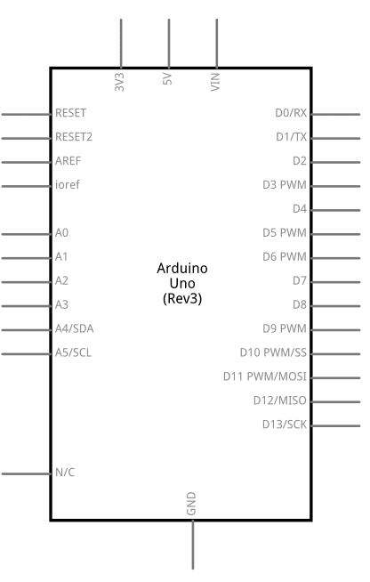
Arduino Uno

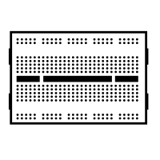
Breadboard

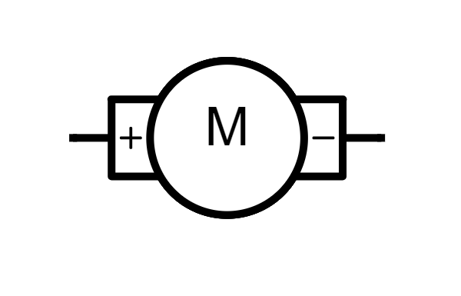
DC Motor

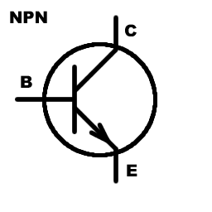
NPN Transistor

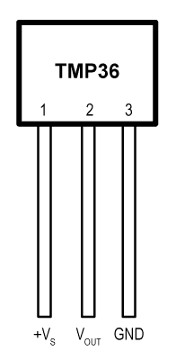
Temperature Sensor [TMP36]

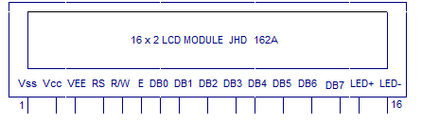

16*2 LCD Module

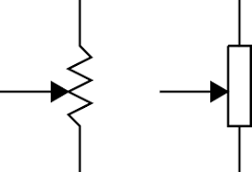

250 Kilo Ohm Potentiometer


221 Ohm Resistor

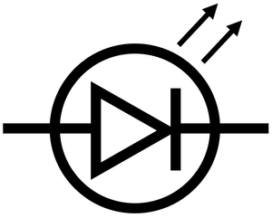
LED

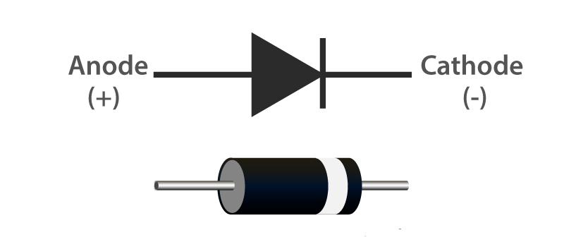

Diode

CHAPTER 1

INTRODUCTION

The concept of this paper is to create an automatic room temperature control system to control the temperature of a room. This circuit maintains the temperature of the room in a particular range. Automatic control plays an ever-increasing role in human way of life. During winter and summer season, room temperature must be maintained in order to ensure the human convenience. This project mainly includes the temperature control of surrounding in winter and summer. It consists of Temperature sensing unit, LCD module, a fan and heater. It will operate based on the value or range of Temperature in the system which is detected by Temperature of the sensor. The Temperature sensor detect the temperature of the room. The Temperature sensor is connected to the Arduino. It converts the analog input to digital value. It is use to switch on the heater and fan. The LCD module is also connected to the Arduino. The module displays the current temperature. The LCD display used is a 16x12 Alphanumeric display.

1.1 Project Background

Nowadays, the air conditioning is widely used especially in warm countries including India. Usually, the conventional air conditioning is always cooling the room depending on the fixed temperature setting and is not automatically adjusted for the comfort of the users. In the central air conditioning control field, excellent real-time, high reliability, and good intelligence are proposed by many researchers. The traditional PID algorithm is, in fact, still playing a main role in the control process. The air conditioning system has become a field to be researched to improve the user convenience by applying intelligent system.

While the enhanced air conditioning system is being designed, the consideration of the type of control system must be included in a modeling design. In particular the controller must be able to avoid the inefficiency of having the air conditioning operate all the time. Several control options were considered at presence sensing circuit, which would turn the air conditioning off when people are not in the room with the air conditioning and a temperature sensor input, which would change the air conditioning operation depending on room temperature.

1.2 Problem Statement

The problem happens when the air conditioning is still functioning although in the event of cold weather. The function is uncontrolled and must be manually turned on and off. Sometimes it can lead to high usage of electricity which in turn raises the electricity bill when the user forgot to switch it off. To address the problem, the automatic room temperature control that can control the temperature automatically is proposed. The advantages of such a system are less energy usage, and provides more convenient to the consumers.

1.3 Objectives

The objectives of this project are:
1. To record voltage outputs across the TMP36 sensor, fan and heater when they are in operation.
2. To test its applicability in different temperature ranges as measured by the TMP36 temperature sensor.
3. To analyses the performance of the controller.

1.4 Scope of The Project

The project is making use of a fan and a heater with the circuit systems in it. The scope of this project is:
- To design a system that sets the desired temperature value range.
- Automatic temperature sensor monitoring the recent change of temperature within the range.
- Heater/fan functioning within desired temperature range(s).
- Automatically sets the room temperature within 20 to 25 degrees Celsius.

CHAPTER 2
LITERATURE SURVEY

2.1 Related work

In the past few years, the need for automation has increased and has been widely applied to cooling and heating systems. There are plenty of commercial temperature control systems which can be bought from manufacturers or inventors, and also, quite a lot of work has been published in this area.

In a related invention (Hedges,1947), R.E. Hedges invented an automatic temperature control systems intended at automatically controlling the temperature of an object or a region so as to continuously maintain the said temperature at a constant value. In his design, the temperature control system can only control a single heat source. It is difficult therefore to attain temperature control of systems emitting simultaneously and in combination of the desirable features of large capacity, high response, and accuracy.

In 1992 (Ian,1992), Ian Bell invented a self-programmable heating and cooling system, which is based on temperature control system. This system is not easy to operate and can only be operated by experts as it has to be interfaced with a computer anytime the re-programming is needed.

M. R. Levine (Levine, 2013) invented an automatic temperature adjusting system for an air conditioner room. The automatic temperature adjusting system for the air conditioner room was made simple in operation and was capable of monitoring the temperature of the human body at any time in the air-conditioned room and transmits the corresponding signals to the air conditioner in time. The air conditioner conducts adjustment, so that the health of people is guaranteed. However, this is also a one-time programming and it is needed to be interfaced with the computer anytime reprogramming is needed, hence, the operation of the system becomes complex.

Other automatic temperature controller systems that have been designed and published include;
- Automatic temperature control for transport airplanes (Hedges, 1947).
- Wireless thermostat and room environment control system. (Tate and Ries,1990)
- Automatic temperature control system. (Minoru, 1996),
- Automatic heater controller. (Poll,2006).
- Design of automatic temperature control system on laser diode of erbium-doped fiber source, in: Proceedings of (Chengxiang, Zhenhua, Xu and Feng, 2011).
- Design of automatic temperature-control circuit module in tunnel microwave heating system. (Fu, Wang and Yang, 2011).

These designs are not easy to use in terms of programming and temperature adjustment. The systems work on the benefits of using temperature adjustable and fan temperature control 12 systems. These systems are either one time programmable or need analog adjustment which is not accurate and more difficult to use.
More recent, real time-based temperature control using Arduino was published (Amoo et al,2014). The system uses Arduino based on ATMEL 89C51, which is just one of the applications of Arduino. The system is not simple in terms of operation as it is tedious to change the reference temperature. The system is similar to the ones presented by the authors in the following systems:
- A precision temperature controller using embedded system. (Pimpalgaonkar et al, 2011).
- Design and experiment about temperature control system of sealing machine based on Fuzzy PID. (Cao et al, 2011).

Other works based on temperature control do exist in different areas and different applications. Such work such as electric cable interference temperature monitoring in power transmissions, server room temperature measurement using Bluetooth embedded system (Loup et al, 2011), control system for communication room using wireless temperature monitoring system (Bing and Wenyao, 2011) and temperature sensor and Zigbee based temperature measurement (Pengfei et al, 2011) do exist. These systems have the same problem of cost as well as the need for experts in re-programming.

This leaves a gap for the design of a system that is not only simple, cost effective, efficient, easy to program and one that minimizes components so as to reduce the size of the design. The automated room temperature controller system thus comes in handy to provide solutions to the gaps that can be noted in the previous systems. It is simple, cost effective and can be used to provide real-time air conditioning for both home and commercial institutions.

2.2 Sensors

A sensor can be defined as a device that measures a physical quantity such as temperature, light, motion or any other physical phenomenon and converts it into an electrical signal (Mengistie, 2018). Examples of sensors include temperature sensors, humidity sensors, motion detection sensors, oxygen sensors and infrared sensors. The output of sensors is usually current, charge and voltage. Temperature sensors are devices that are temperature sensitive, and respond to changes in temperature.

There are 2 kinds of temperature sensors:
1) Contact sensors
2) Non-Contact sensors.

However, the 3 main types are thermometers, resistance temperature detectors, and thermocouples. All three of these sensors measure a physical property (i.e., volume of a liquid, current through a wire), which changes as a function of temperature. In addition to the 3 main types of temperature sensors, there are numerous other temperature sensors available for use.

2.3 TMP36 Sensor

The TMP36 temperature sensor is an easy way to measure temperature using an Arduino! The sensor can measure a fairly wide range of temperature (-50°C to 125°C), is fairly precise (0.1°C resolution), and is very low cost, making it a popular choice.

Unlike a thermistor, the TMP36 does not have a temperature sensitive resistor. Instead, this sensor uses the property of diodes; as a diode changes temperature the voltage changes with it at a known rate. The sensor measures the small change and outputs an analog voltage between 0 and 1.75VDC based on it. To get the temperature we just need to measure the output voltage and a little bit of math.
Electrical characteristics
Maximum power supply | 5V DC
Minimum power supply | 2.7VDC
Minimum current supply | 0.5mA
Maximum current supply | 2.5mA
Table 2.1. Electrical characteristics of TMP36 sensor

The TMP36 has 3 pins as shown below;
Pin 1: IN 2.7-5.5V DC
Pin 2: Analog Voltage Out
Pin 3: Ground

2.4 Microcontroller
It can be defined as a self-contained system that incorporates a microprocessor for sensing input from the real world and controlling devices based on the input. They consist of a processor, memory and some peripherals. Microcontrollers are used in digital applications for automation and as control units. They work according to a program that is written in their processors. These programs are often written using assembly languages but also high-level languages such as C, C++ PASCAL and Java (Mengistie, 2018).

2.4.1 Alf and Vegard’s RISC Processor (AVR)
A Reduced Instruction Set Computer (RISC) is one whose Instruction Set Architecture (ISA) allows it to have fewer cycles per instruction was developed in 1996 by Atmel corporation. They are loaded with an Integrated Development Environment (IDE) and a C compiler. They contain output and input parts, timers, interrupts, USART.12C interface channels and on chip analog comparators. They are fabricated with Modified Harvard Architecture which allows what is contained in the instruction memory to be assessed as if it were data. However, they are difficult for beginners to work with (Barrett and Pack, 2006).

2.4.2 8051 Microcontroller
It was developed by Intel Corporation in 1980. It processes 8-bit data at a time and their name results from the fact that they can all be programmed using 8051 assembly language (Mazidi, n.d.). Their main drawback is their language of programming. The assembly language used is complex and difficult to use.

2.4.3 Programmable Interface Controller (PIC)
It was originally developed by General Instruments Microelectronics Division. They are affordable and perform better than 8051 microcontrollers. They are better off than 8051 microcontrollers because they have small low pic count devices, however like 8051 microcontrollers they are difficult and cumbersome to program hence cannot be recommended for a beginner.

2.5 Arduino

Arduino is an open-source electronics design platform which is designed for prototyping and programming with Atmel microcontrollers (Arduino, 2018). They interact with physical environment through sensors. They can be made to respond to physical phenomenon and hence are widely used for automation purposes.
Some of Arduino older boards include;
- Arduino NG 240
- Arduino V2
- Arduino Extreme
- Arduino USB V2

2.5.1. Arduino UNO Rev 3
The word UNO means one in Italian and was chosen to mark the release of Arduino software Integrated Development Environment (IDE) (Evans, 2011). This is one type of Arduino boards that is widely used due to the following feature
- They have 8-bit bidirectional input/output pins with internal pull up resistors
- 1 KB Electronic Erasable Programmable ROM
- 32 KB flash memory
- 2 KB of RAM

Arduino UNO is a microcontroller board based on the ATmega328 datasheet. It has 14 digital input/output pins (6 can be used as PWM outputs), 6 analog inputs, a 16MHz crystal oscillator, a USB connection, a power jack, an ICSP header and a reset button.
Examples of inputs: temp sensor, motion sensor, distance sensor, switch etc.
Examples of outputs: -light, screen, motor etc.

Technical specifications
- Microcontroller- ATmega328
- Operating Voltage- 5V
- Supply Voltage (recommended)- 7-12V
- Maximum supply voltage (not recommended)- 20V
- Digital I/O Pins 14- (of which 6 provide PWM output)
- Analog Input Pins- 6
- DC Current per I/O Pin- 40 mA
- DC Current for 3.3V Pin- 50 mA
- Flash Memory- 32 KB (ATmega328) of which 0.5 KB used by bootloader
- SRAM 2 KB- (ATmega328)
- EEPROM- 1 KB (ATmega328)
- Clock Speed- 16 MHz
- LED_builtin- 13
- Length-68.6mm
- Width-53.4mm
- Weight-25g

- USB TO PC: It is used to communicate Arduino via Universal Serial Bus to PC for programming/sending data to Arduino serially. 19
- 7V to 12V DC input: - For external supply voltage. The recommended voltage range is 7-12V. A 9V battery can also be used to power the Arduino UNO.
- Reset Button: - It resets the Arduino board if pressed.
- ICSP: -An abbreviation for In Circuit Serial Programming which consists of MOSI, MISO, SCK, RESET, VCC and GND. It is either used to Programme USB or Microcontroller. It allows the user to Programme the microcontroller when it is in circuits i.e. it allows to Programme ATmega328p-pu directly with AVR instructions without using Arduino IDE.
- SDA: - SERIAL Data; it is the bidirectional data line that is used by 12c.
- SCL: - Serial Clock; it is used to indicate that data is ready on bidirectional data line that is used by 12C.
- AREF: - Analog Read Reference; it is mainly used for analog reference () function calls, as default it is not required but to use it you have to add some voltage source between 0V to 5V in AREF pin which will be considered as accurate reference voltage.
- GND: - Ground
- SCK: - Serial Clock, which is used by SPI (Serial Peripheral Interface). It is clock generated by a master which is used to clock the data to the slave.
- MOSI: - Master out Slave In; the data transmitted from master to slave
- MISO: - Master in Slave Out; the data transmitted to master from slave
- SS: -Slave Select; it is used to select the ‘slave’. Make high to SS pin to deactivate and make low to activate it.
- INT1&INT0: - These are hardware interrupts. It calls the ISR (Interrupt Service Routine) when the pin change occurs
- TX: - Transmit; it is used to transmit TTL serial data. Also referred to as ‘outwards’ since it transfers data from Arduino to the connected peripheral.
- RX: -Receive; it is used to receive TTL serial data. It is also referred to as inwards since it receives data from external hardware to Arduino.
- Vin: - Voltage In; if Arduino board is powered from USB then nothing is obtained from the Vin pin. But if the board is powered directly with an external supply, then that supply is obtained directly from Vin pin. However, the supply voltage obtained at the Vin pin is usually lesser by 1V than the voltage supplied due to reverse polarity protection diode.
- 5V Pin: - it is used to power external components connected to Arduino which needs 5V.
- 3.3V Pin: - it is used to power external components connected to Arduino that need 3.3V.
- IORef: - Input Output Voltage Reference; it allows shields connected to Arduino board to check whether the board is running at 3.3V or 5V

2.6 LCD (Liquid Crystal Display)

The most basic and commonly used LCDS are the 16×12 because they are cheap, easy to program and can display wide range of characters. This is a 16-pin device which displays 16 × 2 characters. In this project the 16×12 LCD is used to display the state of heater or fan and the TMP36 readings.

CHAPTER 3

DESIGN FLOW/PROCESS

3.1 Introduction
Weather changes become hard to adapt. That is, during Winter we face difficulties tolerating the freezing cold, and that is why people often prefer wearing coats during the season. On the other hand, the weather becomes too warm in summer. Thus, having understood the switching operation of transistors, unidirectional current flow in diodes, the principle of operation of motors, the resistance from resistors combined with the transformation capability of the transducer, the temperature sensor in this case.

If the temperature exceeds the maximum of the aforementioned "desired" range, then the LCD displays that the temperature is higher and informs the FAN to turn on. Then the FAN starts its rotation/vibration, and after a while the temperature gets lowered falling in the range, then the LCD commands the FAN to turn off.
Whenever the sensor's temperature reading goes down below the possible minimum temperature in the range, the LCD notifies that the temperature is LOWER and tells the heater to be turned on, and after the temperature is in the range, it displays that temperature is OK and orders the heater to be switched off.

The last condition is whenever the temperature is within the desired range, the LCD tells that the temperature is normal. Thus, it asks to turn off everything. This condition can, for instance, be observed if you run the code and the slider's position remains unchanged. That tells one that the default slider position is within the desired room temperature range (i.e., the default is 24.78 degree C).

Likewise, system iterates forever unless it gets terminated by the user due to the behavior of the loop () function.

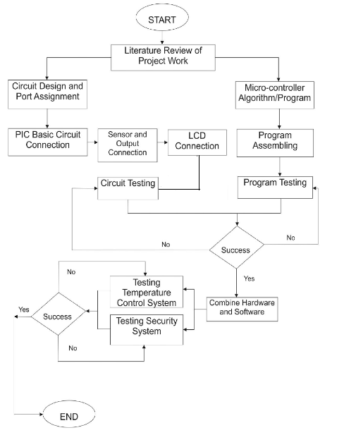
Fig 3.1 Flowchart for automatic room temperature controller

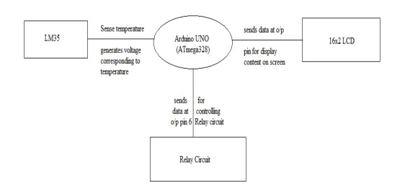
Fig 3.2 Data Flow Diagram
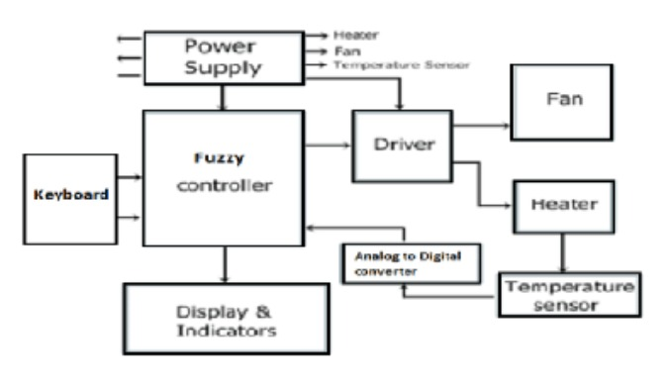
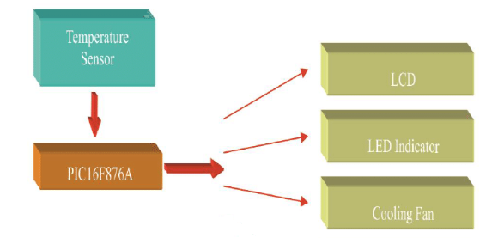
Fig 3.3 Block Diagram
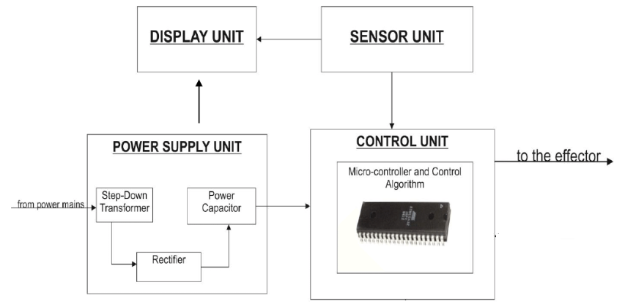
Fig 3.4 Project Channel for automatic room temperature controller

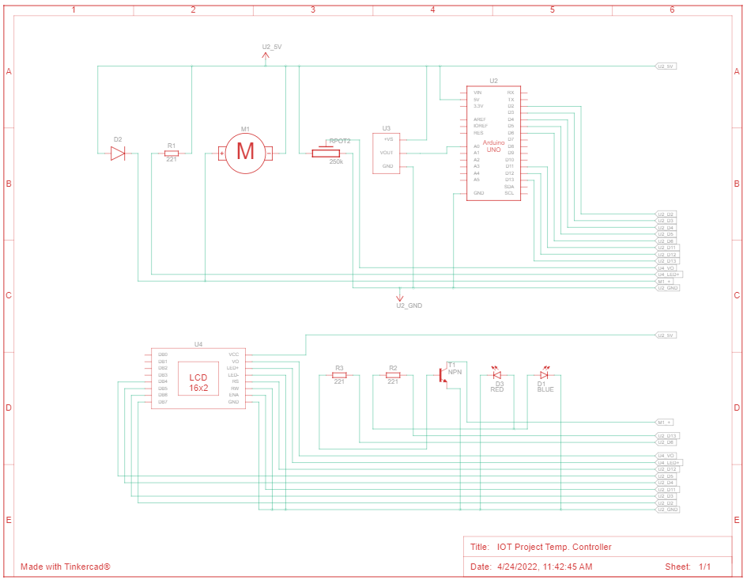
Fig 3.5 Circuit Diagram for automatic room temperature controller
CHAPTER 4

RESULTS ANALYSIS AND VALIDATION

4.1 Report preparation
The concept of this report is to create an automatic room temperature control system to control the temperature of a room. This circuit maintains the temperature of the room in a particular range. Automatic control plays an ever-increasing role in human way of life. During winter and summer season, room temperature must be maintained in order to ensure the human convenience. This project mainly includes the temperature control of surrounding in winter and summer. It consists of Temperature sensing unit, LCD module, a fan and heater. It will operate based on the value or range of Temperature in the system which is detected by Temperature of the sensor. The Temperature sensor detect the temperature of the room. The Temperature sensor is connected to the Arduino. It converts the analog input to digital value. It is use to switch on the heater and fan. The LCD module is also connected to the Arduino. The module displays the current temperature. The LCD display used is a 16x12 Alphanumeric display.

4.2Arduino
Arduino is an open-source electronics design platform which is designed for prototyping and programming with Atmel microcontrollers (Arduino, 2018). They interact with physical environment through sensors. They can be made to respond to physical phenomenon and hence are widely used for automation purposes.
Some of Arduino older boards include;
- Arduino NG 240
- Arduino V2
- Arduino Extreme
- Arduino USB V2
This is one type of Arduino boards that is widely used due to the following feature
- They have 8-bit bidirectional input/output pins with internal pull up resistors
- 1 KB Electronic Erasable Programmable ROM
- 32 KB flash memory
- 2 KB of RAM

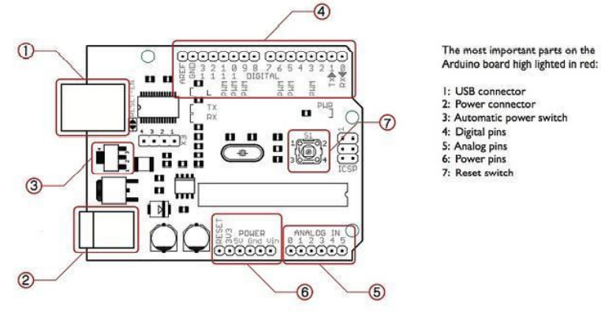
Figure 4.1 Arduino uno pins

Arduino UNO is a microcontroller board based on the ATmega328 datasheet. It has 14 digital input/output pins (6 can be used as PWM outputs), 6 analog inputs, a 16MHz crystal oscillator, a USB connection, a power jack, an ICSP header and a reset button.
Examples of inputs: temp sensor, motion sensor, distance sensor, switch etc.
Examples of outputs: -light, screen, motor etc.
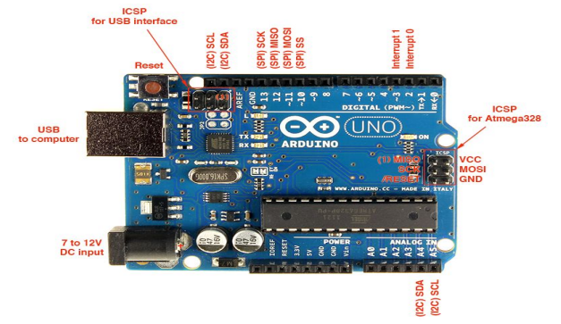
Figure 4.2 Arduino uno pins

4.2.1 Programming of Arduino uno.
Arduino UNO is programmed in C/C++ language. The first step to programming Arduino is to download the Arduino software package (desktop version) from the Arduino download page. Once downloaded and installed, when one launches, it gives the page below:
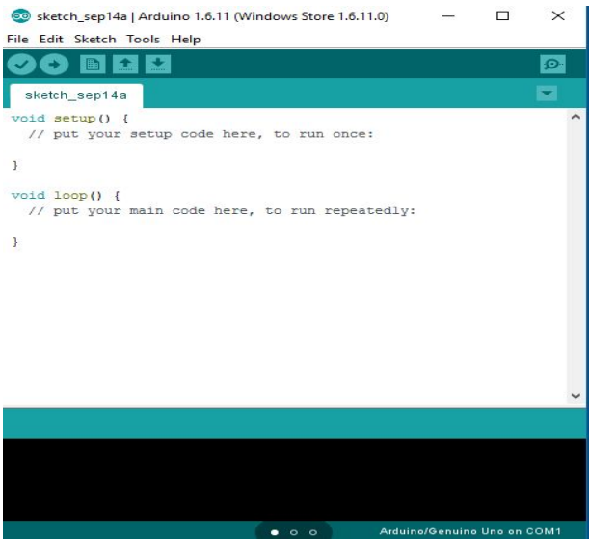
Figure 4.3 A sketch of Arduino IDE window
4.3 Breadboard Supply
If we want to easily power the components on your breadboard, then a Breadboard Power Supply Module is the right choice. It provides dual output voltages: 3.3V and 5V on two different power rails.
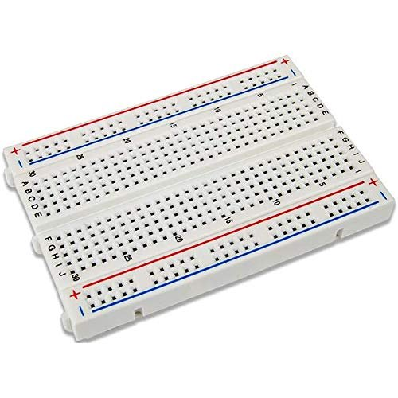
Fig4.4 Breadboard Power Supply
This module will perfectly fit on to 400-point and 800-point breadboards. The input range is 6.5V to 12V.
4.4 LCD Display
The LiquidCrystal library allows you to control LCD displays that are compatible with the Hitachi HD44780 driver. There are many of them out there, and you can usually tell them by the 16-pin interface.
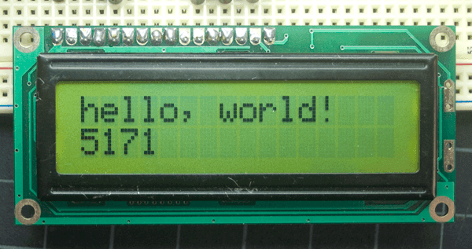
Fig 4.5 Output of the sketch on a 16x2 LCD
The LCDs have a parallel interface, meaning that the microcontroller has to manipulate several interface pins at once to control the display.

Pin Number | Function | Symbol
1 | Ground (0V) | VSS
2 | Supply Voltage (5V) | VDD
3 | Contrast adjustment; through a variable resistor(potentiometer) | V0
4 | Selects command register when low; and data register when high | RS
5 | Low to write to the register; High to read from the register | RW
6 | Sends data to data pins when a high to low pulse is given | E
7 | 8-bit data pins | D0
8 | 8-bit data pins | D1
9 | 8-bit data pins | D2
10 | 8-bit data pins | D3
11 | 8-bit data pins | D4
12 | 8-bit data pins | D5
13 | 8-bit data pins | D6
14 | 8-bit data pins | D7
15 | Backlight Vcc (5V) | A
16 | Backlight Ground (0V) | K

Table 2.2. LCD pins ant their connections

4.5 Temperature Sensor
The TMP36 temperature sensor is an easy way to measure temperature using an Arduino! The sensor can measure a fairly wide range of temperature (-50°C to 125°C), is fairly precise (0.1°C resolution), and is very low cost, making it a popular choice.
To get the temperature we just need to measure the output voltage and a little bit of math.
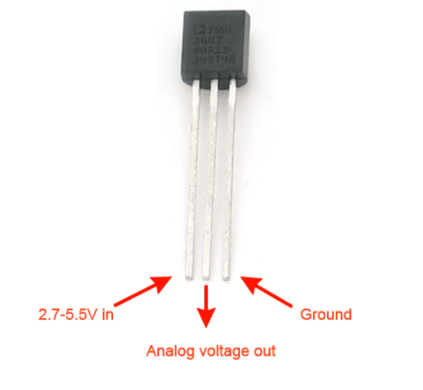
Fig 4.6 TMP36 Temperature sensor

4.6 Heater (LED)
In this module we can use LED instead of heater for only temporary purpose. This module can work only when the temperature of the room decreases. It will start glowing the LED instead of heater that means our heater is started. This module can start when the temperature sensor gives the reading less than 20 degrees Celsius. The time span for this module can be completed in half month.

4.7 Cooling (DC Motor)
In this module we can use DC Motor instead of cooling for only temporary purpose. This module can work only when the temperature of the room increases. It will start rotating the DC Motor instead of Fan that means our cooling is started. This module can start when the temperature sensor gives the reading more than 25 degrees Celsius. The time span for this module can be completed in half month.

4.8 8051 Microcontroller
It was developed by Intel Corporation in 1980. It processes 8-bit data at a time and their name results from the fact that they can all be programmed using 8051 assembly language (Mazidi, n.d.). Their main drawback is their language of programming. The assembly language used is complex and difficult to use.
4.9 Diode
This is a semiconductor device that has unidirectional current flowing it is forward or backward biased. It can be used as a voltage regulator tuning device, frequency multiplying device, mixing device, etc. For this project the semiconductor diode is used and it is connected to the fan that acts as the Cooling part. Electrical and pictorial symbol of a diode
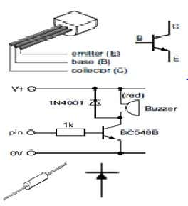
Fig 4.7 Diode 1N4007
4.10 Transistor
Transistor is an electrical component that controls the current flow in a circuit. A transistor acts as an ‘electrical switch’ so that small current can control large current. For example, the low-current devices like microcontroller controlling the large-current devices like motors. Transistors are used in radios, electronic toys, electronic staplers, etc. Transistor has three legs which are labelled base, collector, and emitter. The base leg activates the ‘electronic switch’. So, when small current passes through the base connection, it allows a much larger current to flow down between the collector and emitter. This larger current is then used to switch on devices like motors, lamps and buzzers. For this project, NPN bipolar transistor is used
Fig 4.8 Transistor

4.11 Communication
Nowadays, the air conditioning is widely used especially in warm countries including India. Usually, the conventional air conditioning is always cooling the room depending on the fixed temperature setting and is not automatically adjusted for the comfort of the users. In the central air conditioning control field, excellent real-time, high reliability, and good intelligence are proposed by many researchers. The traditional PID algorithm is, in fact, still playing a main role in the control process. The air conditioning system has become a field to be researched to improve the user convenience by applying intelligent system.

While the enhanced air conditioning system is being designed, the consideration of the type of control system must be included in a modeling design. In particular the controller must be able to avoid the inefficiency of having the air conditioning operate all the time. Several control options were considered at presence sensing circuit, which would turn the air conditioning off when people are not in the room with the air conditioning and a temperature sensor input, which would change the air conditioning operation depending on room temperature. Based on the observation of the using the present conventional air conditioning application, it always working all the time without a systematic control. Therefore, the control of the air conditioning is adjusted through a feedback control system to monitor and maintain a constant temperature based on the data input from the sensor.

In the past few years, the need for automation has increased and has been widely applied to cooling and heating systems. There are plenty of commercial temperature control systems which can be bought from manufacturers or inventors, and also, quite a lot of work has been published in this area.

In a related invention (Hedges,1947), R.E. Hedges invented an automatic temperature control systems intended at automatically controlling the temperature of an object or a region so as to continuously maintain the said temperature at a constant value. In his design, the temperature control system can only control a single heat source. It is difficult therefore to attain temperature control of systems emitting simultaneously and in combination of the desirable features of large capacity, high response, and accuracy.

In 1992 (Ian,1992), Ian Bell invented a self-programmable heating and cooling system, which is based on temperature control system. This system is not easy to operate and can only be operated by experts as it has to be interfaced with a computer anytime the re-programming is needed.

M. R. Levine (Levine, 2013) invented an automatic temperature adjusting system for an air conditioner room. The automatic temperature adjusting system for the air conditioner room was made simple in operation and was capable of monitoring the temperature of the human body at any time in the air-conditioned room and transmits the corresponding signals to the air conditioner in time. The air conditioner conducts adjustment, so that the health of people is guaranteed. However, this is also a one-time programming and it is needed to be interfaced with the computer anytime reprogramming is needed, hence, the operation of the system becomes complex.

Other automatic temperature controller systems that have been designed and published include;
- Automatic temperature control for transport airplanes (Hedges, 1947).
- Wireless thermostat and room environment control system. (Tate and Ries,1990)
- Automatic temperature control system. (Minoru, 1996),
- Automatic heater controller. (Poll,2006).
- Design of automatic temperature control system on laser diode of erbium-doped fiber source, in: Proceedings of (Chengxiang, Zhenhua, Xu and Feng, 2011).
- Design of automatic temperature-control circuit module in tunnel microwave heating system. (Fu, Wang and Yang, 2011).
More recent, real time-based temperature control using Arduino was published (Amoo et al,2014). The system uses Arduino based on ATMEL 89C51, which is just one of the applications of Arduino. The system is not simple in terms of operation as it is tedious to change the reference temperature. The system is similar to the ones presented by the authors in the following systems:
- A precision temperature controller using embedded system. (Pimpalgaonkar et al, 2011).

Other works based on temperature control do exist in different areas and different applications. Such work such as electric cable interference temperature monitoring in power transmissions, server room temperature measurement using Bluetooth embedded system (Loup et al, 2011), control system for communication room using wireless temperature monitoring system (Bing and Wenyao, 2011) and temperature sensor and Zigbee based temperature measurement (Pengfei et al, 2011) do exist. These systems have the same problem of cost as well as the need for experts in re-programming.

Quality: This project work presents the design of an automatic room temperature controller system. This system allows the user to set a desired temperature between (20’C to 25’C the normal temperature of room) which is then compared to the room temperature measured by TMP36 temperature sensor. With the help of Atmega328P based on Arduino microcontroller, the system responds by turning ON and OFF the two (2) loads (fan or a heater) automatically depending on the temperature difference in the room. The fan is triggered ON when the room temperature is higher than the set temperature and the heater is triggered ON when the room temperature is lower than the set temperature. The system was designed and simulated using Tinkercad, circuit building software used for building electronics system. Tinkercad software was used to design and simulate the main circuit; Arduino IDE was used to write a program on how the system will operate which was then loaded to the microprocessor. An LCD was used to display temperature readings obtained by the TMP36 temperature sensor and the condition of the heater and the fan whether ON or OFF. When the system was simulated the heater and the fan were turned on automatically depending on the room temperature. The heater turned on when the temperature was below 20 degrees Celsius while the fan turned on when temperature fell below the threshold. In both cases, either of them was on at a specified time but not both. When temperature is between 20 to 25 degrees Celsius, the both heater and fan will OFF.

Benefits: Here are some benefits of this project:
- The benefit of the system is less energy usage and it provides more convenience to the user
- It automatically manages temperature of the room.
- Less expensive then air-conditioned.
- It reduces electric power consumption.
- Easily install at any place.
CHAPTER 5

CONCLUSION AND FUTURE WORK

5.1 Conclusion
- This project will solve the day-to day problem where fan or heater do not startup without human effort.
- This will start the fan depending upon the temperature labels in a room by sharing the load.
- Also, this project can be extended for controlling the temperature in more room in an apartment in future.

5.2 User Manual
1. The output of TMP36 sensor is connected to analog input pin A0 of Arduino board. Its Vcc pin (+) is connected to +5 V and Gnd pin (-) to ground
2. Data pins D4, D5, D6 and D7 of LCD are connected to digital pins D5, D4, D3 and D2 respectively. En pin of LCD is connected to pin 11 and Rs pin is connected to pin 12
3. RW pin is connected to ground
4. A 250K pot is connected to 3rd pin VEE of LCD to vary its brightness
5. LED+ terminal and LED- terminal are connected to 5V and ground to turn on LED back light for LCD
6. The anodes of three RED, GREEN and BLUE LEDs are connected to digital pins 6, 7 and 8 through 220Ω current limiting resistors. Their cathodes are shorted and connected to ground
9. The analog output pin 9 drives DC motor (Fan) through transistor. Pin 9 is connected to base of transistor through current limiting resistor R2 and the collector output drives DC motor.

The TMP36 sensor give 0 to 1 V output as 10 mV/ degrees C – means as temperature varies by 1 degrees C the output voltage from sensor increases by 10 mV and vice versa. Because the output of sensor is connected to analog input of arduino it will convert this into digital value from 0 to 1023· Because TMP36 sensor output is limited to 0 – 1 V only, and reference voltage for internal ADC is 5 V, so the output of sensor is multiplied by 5 to get full range· So as temperature increases, the analog output from sensor increases from 0 to 1 V and arduino generates corresponding digital value from 0 to 1023· So 0 to 1 V range is divided in 1024 steps – means each step has 1/1024 = 0.00097 = 0.97 mV resolution· Because TMP36 sensor output changes by 10 mV on each 1 degrees C change in temperature, so when analog reading changes by 10 / 0.97 = 10.31, it indicates temperature changes by 1 degrees C· So arduino reads analog voltage output from sensor, gets analog value between 0 to 1023 divide it by factor 10.31 and displays this value on LCD as current temperature· Arduino gets set temperature value from pot R1. As pot is varied the analog voltage input varies from 0 to 5V and its corresponding output varies as 0 to 1023. It is mapped between 0 to 100 as set temperature between 0 – 100 degrees Celsius. So, one can set the temperature between 0 degrees C to 100 degrees C by varying pot and it is displayed as set temperature on LCD· Both actual temperature and set temperature are sent to PC through serial port and displayed on serial monitor of arduino IDE. Now if the actual temperature sensed by TMP36 is within ±5 degrees C of set temperature (reference) then LCD displays message “temperature is within limit” and it turns ON GREEN LED. But if actual temperature increases more than 5 degrees C of set temperature then RED LED turns ON and fan speed is increase by increasing the pulse width at pin 9. Similarly, if actual temperature decreases less than 5 degrees C of set temperature then BLUE LED turns ON and fan speed is decreased.

5.3 References
The web sites that provide the information’s:
www.microchip.co.uk
www.quora.com
www.geeksforgeeks.com
www.wikipedia.com
www.engineeringproject.com
www.electronicsworldforyou.com
www.tinkercad.com
www.arduinoide.com
Arduino. (2018). Arduino - Software. https://doi.org/28/12/2008s
[1].Mustafa saad and HossamAbdoalgade,Automatic fan speed control system using microcontroller, International Conference on Electrical Electronic and Civil Engineering, November 2013.
[2]Zairi Ismael Rizmam, Design an Automatic Temperature Control System for Smart Electric Fan Using PIC, International Journal of Science and Research(IJSR), Volume 2, Issue 9, September 2013.
[3]. Vaibhav Bhatia, Room Temperature based Fan Speed Control system using Pulse Width Modulation Technique, International Journal of Computer Applications, Volume 85- No 5, November 2014.
[4]. A.L.Amoo, Design and Implementation of a Room Temperature Control System: Microcontroller- Based, IEEE, 2014.
[5]. DilrubaYamin, Automatic Room Temperature Controlled Fan Speed Controller Using PT-100, International Jounal of Scintific and Engineering Research, Volume 6, Issue 8, August 2015.
[6]. Kunalsingh, Automatic Fan Speed Control System using Arduino, International Journal of Novel Research and Development, Volume 2, Issue 4, April 2017.
[7]. E.HarshavarthanGoud, Real Time Based Temperature control Using Arduino, International Journal of Innovations in Engineering and Technology, Volume 8, Issue, April 2017.
[8]. Surajkaushik, Automatic Fan Speed Control using Temperature and Humidity Sensor and Arduino, International Journal of Advance Research, Ideas and Innovations In Technology, Volume 2, Issue 8, 2018.
[9]. M.Kumaran, Design of an Automatic Fan Speed Controlling System using Arduino UNO, International Journal of Intellectual Advancemaents and Research in Engineering Computations, Volume 6, Issue 2, 2018.
[10]. Joseph chuma, Design and Simulation of an Automatic Room Heater Control System, BostwanaInternational University of Science and Technology, 2018.

